

Company

Logotype

**Cone Beam Computed Tomography- Report**

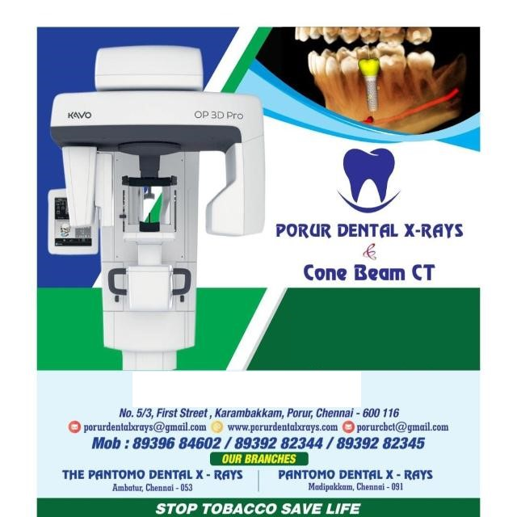



**Porur Dental X-rays & CBCT**

|  |  |
| --- | --- |
| **Patient Name :** Mr. Keshavraj | **Date of Report :** 15.06.2024 |
| **Age/ Gender :** 17 years/ Male | **Region of Interest :** CBCT Full Skull |
| **Referring doctor:** Dr. Aravindhan | **Indication :** Swelling lower front teeth region |
| **Clinical Notes:** Nil | |

**PATIENT INFORMATION**

CBCT Full Skull provided

**CBCT – IMAGE DETAILS**

**RADIOGRAPHIC INTERPRETATION**

* No of teeth present: 31, Missing tooth: 21.
* In relation to the periapical aspect of 31, 32, 41, 42, presence of a single, expansile, unilocular, hypodense area bounded by a corticated margin measuring 12.6 x 25 x 11 mm in dimension.
* The hypodense region appears to be in contact with the apical portions of 31, 32, 41, 42 and appears to cause extreme thinning of the labial and lingual cortical plates.
* The tooth 43 is impacted, appears to be horizontally placed, located in the 3rd quadrant along the lower border of mandible, at a distance of 6.5 mm from the apical region of 35, 36.
* The crown of the impacted 43 is in contact with the inferior alveolar nerve canal.
* The right maxillary sinus is present with mucosal thickening in relation to the floor of the sinus.
* The right nasal pathway is narrow and compromised compared to the left side.

**RADIOGRAPHIC IMPRESSION**

* Differential Diagnosis (based on the visible radiological features): Periapical pathology in relation to 31, 32, 41, 42 suggestive of Radicular cyst.
* Impacted 43.
* Right maxillary sinusitis.

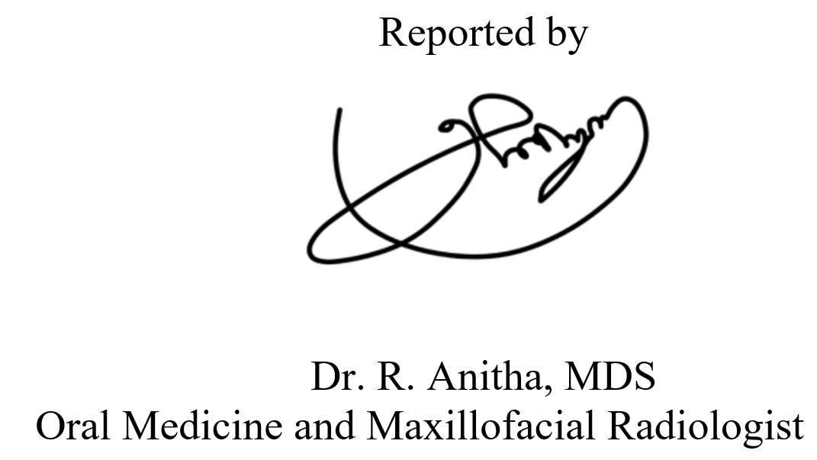*Kindly correlate with clinical and histopathological features*

**IMAGES FOR REFERENCE**

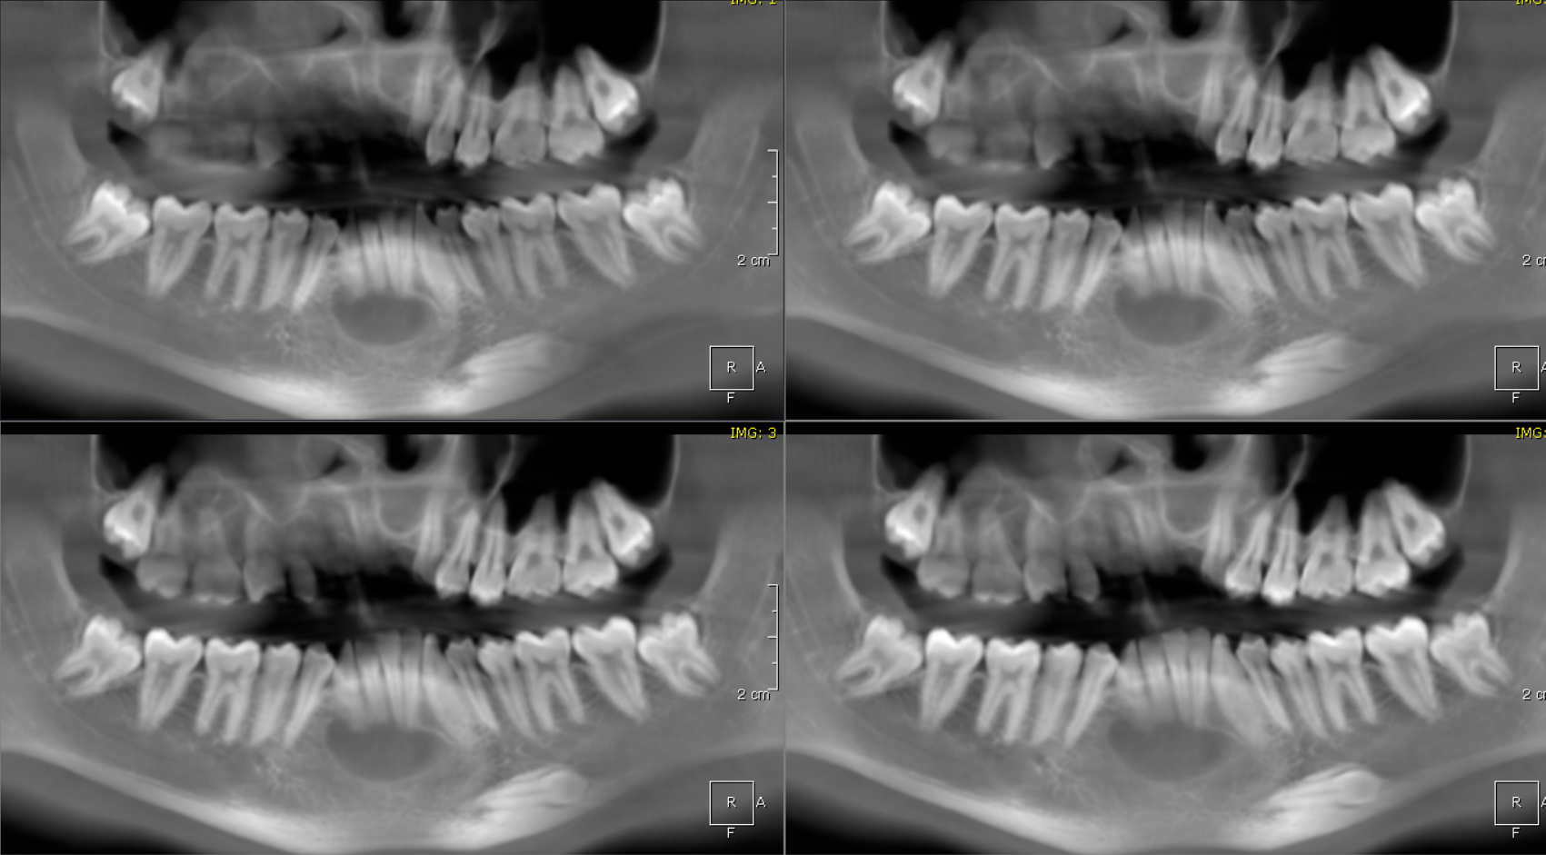

single, expansile, unilocular, hypodense area bounded by a corticated margin

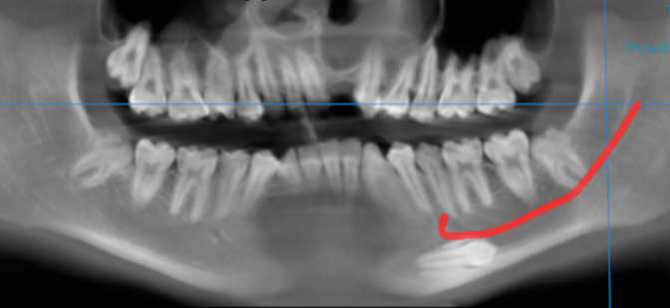

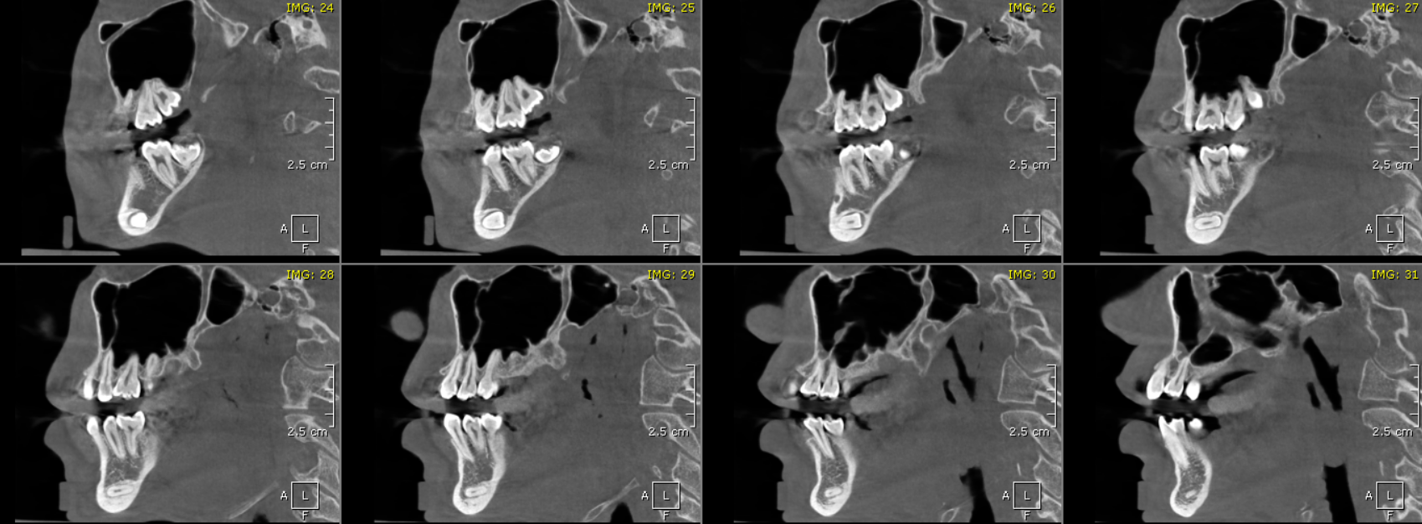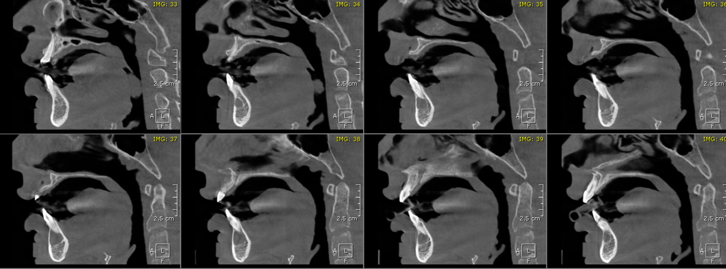

Impacted 43

single, expansile, unilocular, hypodense area bounded by a corticated margin

**SAGITTAL IMAGES FOR REFERENCE**

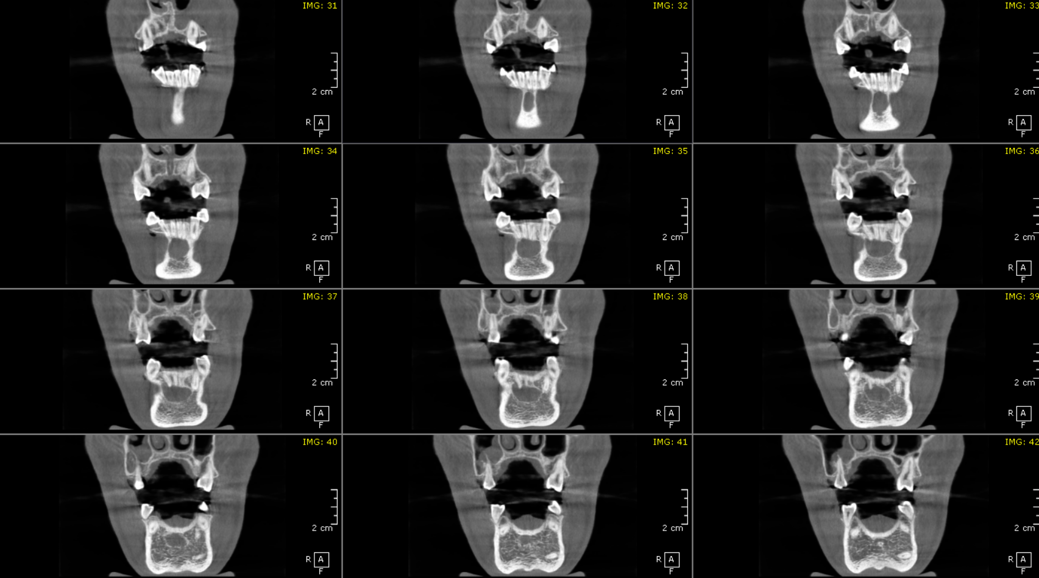

single, expansile, unilocular, hypodense area bounded by a corticated margin

**CORONAL IMAGES FOR REFERENCE**

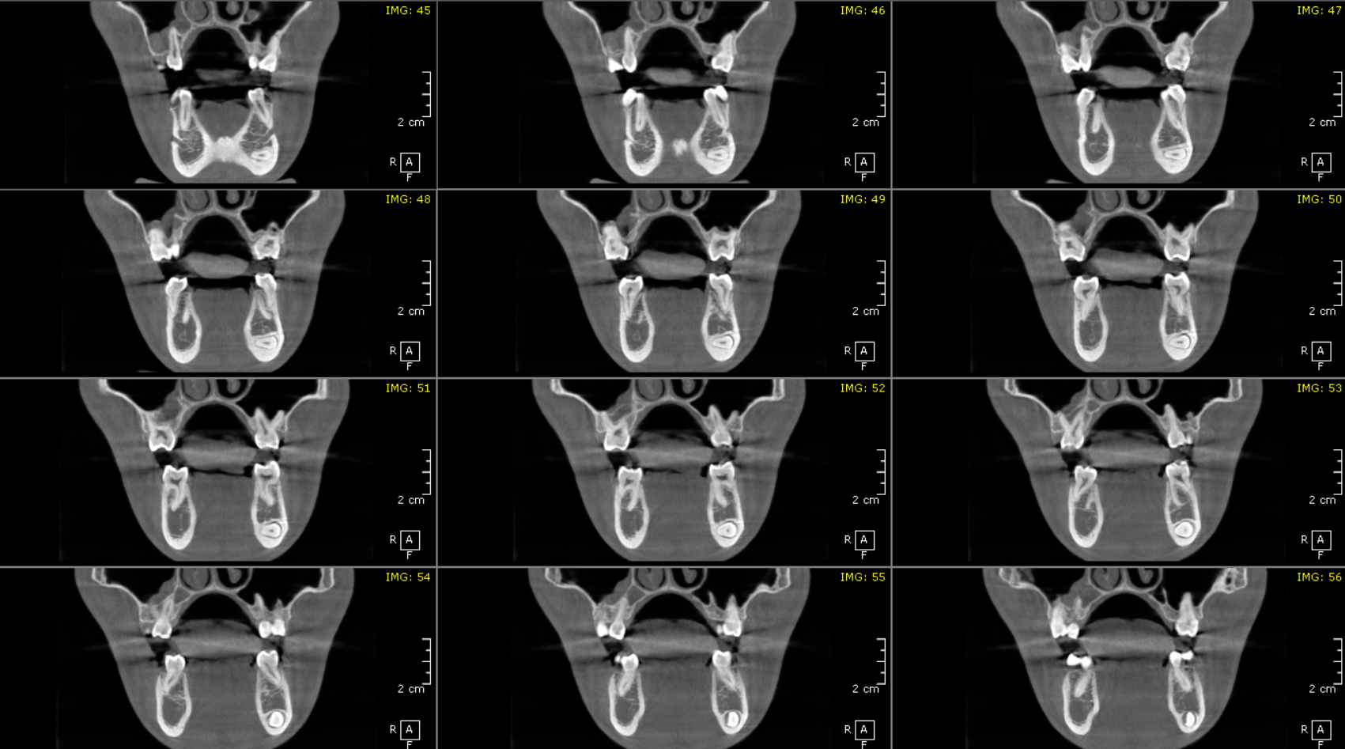

Impacted 43

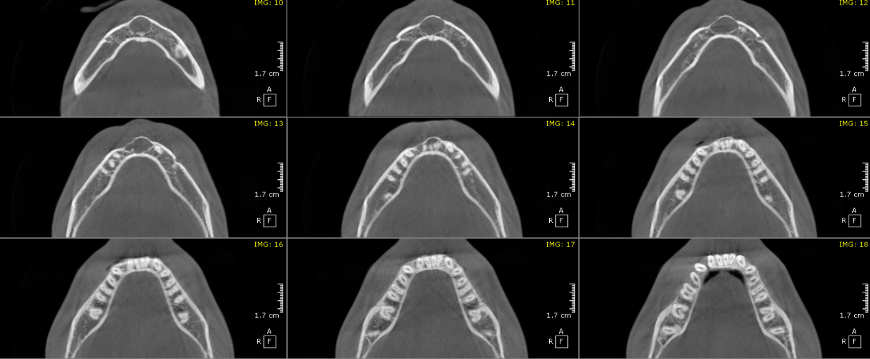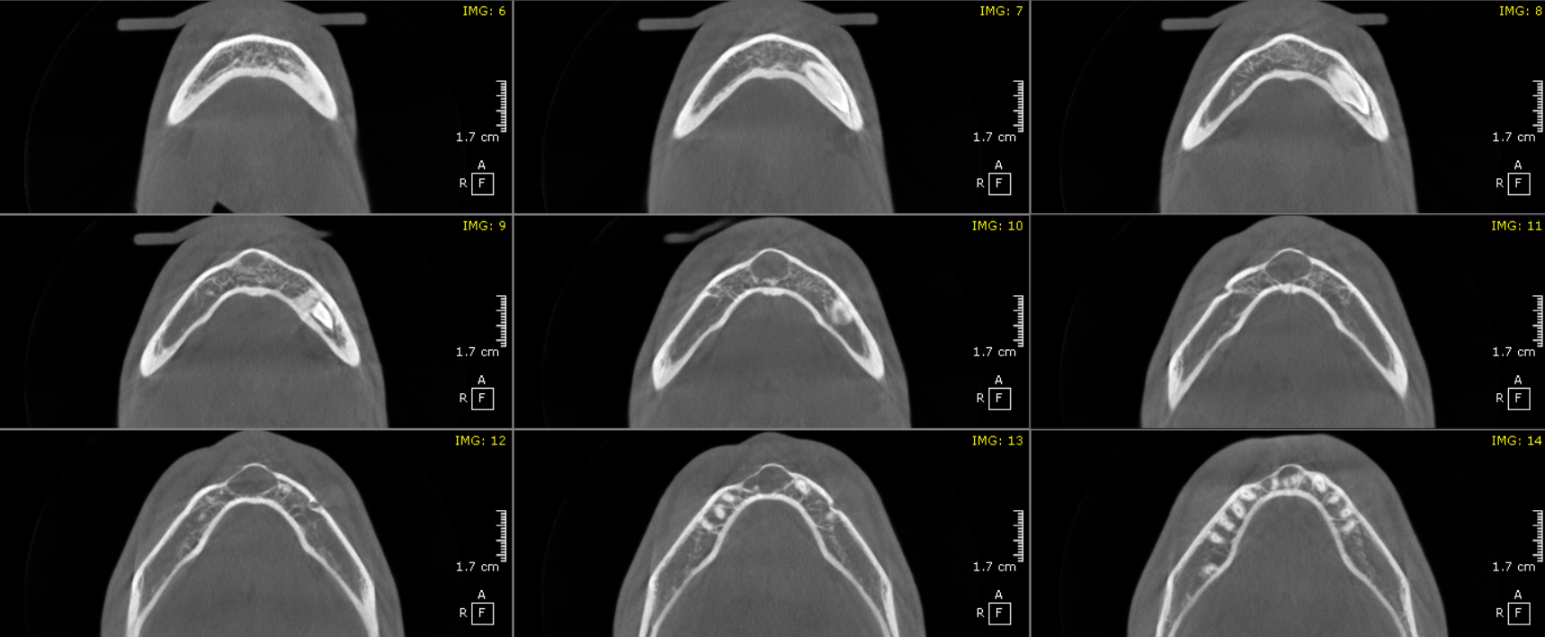

**AXIAL IMAGES FOR REFERENCE**

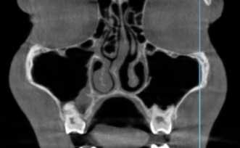

Mucosal thickening

Compromised nasal pathway

**3-DIMENSIONAL VIEW**

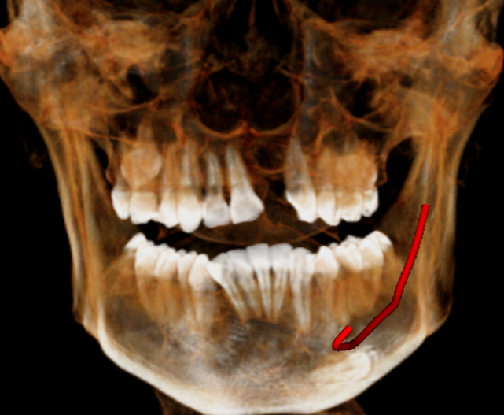

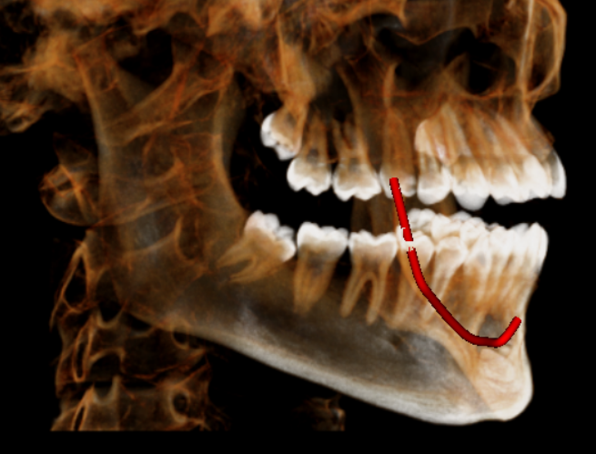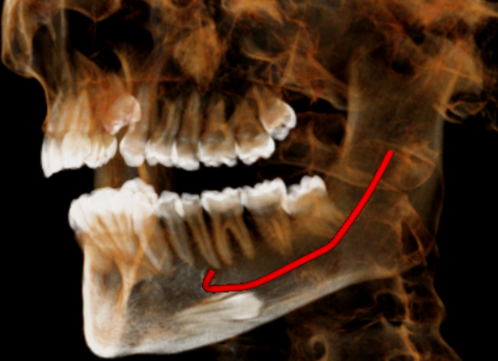

**\*\*\*\* End of report \*\*\*\***